

INTERNAL QUALITY CONTROL ASSESSMENT REPORT*
*insert project photo*
PREPARED BY: | REVIEWED & VERIFIED BY: | ACKNOWLEDGE BY:
Name: | Name: | Name:
Position: | Position: | Position:
Date: | Date: | Date:

PROJECT SITE | :
ASSESSMENT DATE | :
ASSESSMENT DETAILS  (location of the assessment etc.) | :
ASSESSED BY | :
ASSESSOR (S) | :
HEAD OF PROJECT | :
INTERNAL QUALITY SCORING | :

TABLE OF CONTENT

No. | Item | Page No.
1. | Layout Plan
2. | Overall Breakdown Score
3. | Photos of Internal Works Assessment
4. | Photos of External Works Assessment
5. | Attachments related to Assessment

LAYOUT PLAN

OVERALL SCORING BREAKDOWN
Note: please fill in the details in blue & green column
ITEM | ARCHITECTURAL ELEMENTS | TOTAL WEIGHTAGE (%)  (W) | DEFECTS CATEGORY | ∑ NO OF COMPL.  (B) | ∑ NO OF CHECK  (C) | SCORE (%)  E =(B/C)*W
INTERNAL FINISHES
1 | FLOOR | 18 | Finishing
1 | FLOOR | 18 | Alignment & Evenness
1 | FLOOR | 18 | Crack & Damages
1 | FLOOR | 18 | Hollowness
1 | FLOOR | 18 | Jointing
2 | INTERNAL WALL | 18 | Finishing
2 | INTERNAL WALL | 18 | Alignment & Evenness
2 | INTERNAL WALL | 18 | Crack & Damages
2 | INTERNAL WALL | 18 | Hollowness
2 | INTERNAL WALL | 18 | Jointing
3 | CEILING | 8 | Finishing
3 | CEILING | 8 | Alignment & Evenness
3 | CEILING | 8 | Crack & Damages
3 | CEILING | 8 | Roughness
3 | CEILING | 8 | Jointing
4 | DOOR | 8 | Joints & Gaps
4 | DOOR | 8 | Alignment & Evenness
4 | DOOR | 8 | Material & Damages
4 | DOOR | 8 | Functionality
4 | DOOR | 8 | Accessories Defect
5 | WINDOW | 8 | Joints & Gaps
5 | WINDOW | 8 | Alignment & Evenness
5 | WINDOW | 8 | Material & Damages
5 | WINDOW | 8 | Functionality
5 | WINDOW | 8 | Accessories Defect
6 | INTERNAL FIXTURES | 8 | Joints & Gaps
6 | INTERNAL FIXTURES | 8 | Alignment & Evenness
6 | INTERNAL FIXTURES | 8 | Material & Damages
6 | INTERNAL FIXTURES | 8 | Functionality
6 | INTERNAL FIXTURES | 8 | Accessories Defect
7 | ROOF | 10 | Finishing
7 | ROOF | 10 | Rough / Uneven / Falls
7 | ROOF | 10 | Cracks & Damages
7 | ROOF | 10 | Joint / Sealant / Alignment
7 | ROOF | 10 | Chockage / Pounding
7 | ROOF | 10 | Construction
8 | EXTERNAL WALL | 10 | Finishing
8 | EXTERNAL WALL | 10 | Crack & Damages
8 | EXTERNAL WALL | 10 | Alignment & Evenness
8 | EXTERNAL WALL | 10 | Jointing
9 | APRON/ PERIMETER DRAIN | 3 | Drain
9 | APRON/ PERIMETER DRAIN | 3 | Drain Cover
9 | APRON/ PERIMETER DRAIN | 3 | Apron 1
9 | APRON/ PERIMETER DRAIN | 3 | Apron 2
9 | APRON/ PERIMETER DRAIN | 3 | Inspection Chamber
10 | CARPARK/ CARPORCH | 3 | Floor
10 | CARPARK/ CARPORCH | 3 | Columns / Walls
10 | CARPARK/ CARPORCH | 3 | Ceiling
10 | CARPARK/ CARPORCH | 3 | Fixtures
10 | CARPARK/ CARPORCH | 3 | Basic M& E Fittings
11 | MATERIAL & FUNCTIONAL TEST | 6 | Skim coat or prepacked plaster  Wet area water-tightness test
APPLICABLE WEIGHTAGE |  |  | TOTAL (∑ E) =
APPLICABLE ARCHITECTURE SCORE (%)
T = ∑ E / ∑ D * 100

Note: please fill in the details in blue & green column
ITEM | M&E ELEMENTS | TOTAL WEIGHTAGE (%)  (W) | DEFECTS CATEGORY | ∑ NO OF COMPL.  (B) | ∑ NO OF CHECK  (C) | SCORE (%)  E =(B/C)*W
M&E FITTINGS
12 | BASIC M&E FITTINGS |  | Joints & Gaps
12 | BASIC M&E FITTINGS |  | Alignment & Evenness
12 | BASIC M&E FITTINGS |  | Material & Damages
12 | BASIC M&E FITTINGS |  | Functionality
12 | BASIC M&E FITTINGS |  | Accessories Defect
APPLICABLE WEIGHTAGE |  |  | TOTAL (∑ E) =
APPLICABLE M&E SCORE (%)
T = ∑ E / ∑ D * 100

Note: please fill in the details in blue & green column
ITEM | EXTERNAL WORKS ELEMENTS | TOTAL WEIGHTAGE (%)  (W) | DEFECTS CATEGORY | ∑ NO OF COMPL.  (B) | ∑ NO OF CHECK  (C) | SCORE (%)  E =(B/C)*W
EXTERNAL WORKS
13 | EXTERNAL WORKS |  | Fencing & Gate
APPLICABLE WEIGHTAGE |  |  | TOTAL (∑ E) =
APPLICABLE EXTERNAL WORKS SCORE (%)
T = ∑ E / ∑ D * 100

Note: please fill in the details in blue & green column | Highlight in yellow for the category of project |
ITEM | COMPONENTS | RESIDENTIAL BUILDING |  | NON-RESIDENTIAL BUILDING |  | SCORE (%)  T/100*W
ITEM | COMPONENTS | A | B | C | D | SCORE (%)  T/100*W
1 | ARCHITECTURAL WORKS | 85 | 83 | 82 | 80
2 | BASIC M&E FITTINGS | 2 | 3 | 4 | 5
3 | EXTERNAL WORKS | 13 | 14 | 14 | 15
TOTAL ACTUAL COMPONENT (%)
 |  | TOTAL (∑ E) =
OVERALL SCORE (%)
(∑E / TOTAL ACTUAL COMPONENT*100)

REMARKS
NO. | DETAILS
1. | All QLASSIC assessment is done using the latest revision of CIS 7:2021.
2. | Exclusions were made on:  - Internal Finishes:-  - Roof  - Material & Functional Test  - External Works:-  - Link-way/ Shelter  - External Drain  - Roadwork (including parking bay)  - Footpaths and turfing  - Playground  - Court (sports)  - Swimming Pool

PHOTOS OF INTERNAL WORKS ASSESSMENT
Elements | Photos
Floor  Finishing | 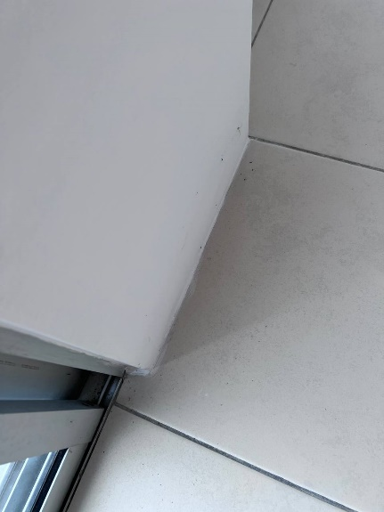 | Paint stain on the floor
Internal Fixtures
Accessories Defect

PHOTOS OF EXTERNAL WORKS ASSESSMENT
Elements | Photos
External Wall | 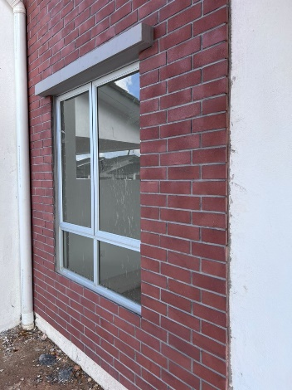 | Finishing problem
Car Park / Car Porch

ATTACHMENTS

